Financial Statement Analysis of National Foods Limited
BS Project
Submitted By
Mian Abdur Rehman Mohsin
BSM-S1-21-09
Muhammad Waqas
BSM-S1-21-05
Muhammad Usama
BSM-S1-21-64
Supervised By
Dr. Faisal Ali

Center For Advanced Studies in Pure and Applied Mathematics
Bahauddin Zakariya University, Multan, Pakistan.

Abstract
This project undertakes a comprehensive financial statement analysis of National Foods Limited, a leading player in Pakistan’s food manufacturing sector, to evaluate its financial health, operational performance, and potential for investment. The study spans a four-year period and is based on a detailed examination of the company’s primary financial documents namely the Income Statement, Balance Sheet, and Cash Flow Statement to understand its financial trajectory and internal dynamics.
The primary aim of this analysis is to provide a holistic assessment of National Foods Ltd.'s profitability, liquidity, efficiency, and solvency through the application of key financial ratios and metrics. These include but are not limited to the gross profit margin, net profit margin, return on equity, current ratio, quick ratio, inventory turnover, asset turnover, debt-to-equity ratio, and interest coverage ratio. By evaluating these indicators, the project identifies trends in the company’s revenue growth, cost management, debt obligations, and cash flow generation.
The methodology involves both vertical and horizontal analysis to assess year-over-year changes and structural composition of financial statements. Ratio analysis is used to benchmark the company's performance against industry standards and historical norms, providing context to the raw financial data. Additionally, key performance drivers and potential risk factors are discussed to give a clearer picture of the company’s strengths, weaknesses, and overall financial resilience which ultimately helps investors determine its suitability as an investment opportunity.

Table of Contents
- Introduction
- Understanding Financial Statements
  - Balance Sheet
  - Income Statement
  - Cash Flow Statement
- Key Financial Ratios and Their Importance
  - Liquidity Ratios
  - Profitability Ratios
  - Efficiency Ratios
  - Leverage Ratios
  - Market Valuation Ratios
- Financial Analysis of National Foods
  - Company Overview
  - Liquidity Position
  - Profitability Performance
  - Operational Efficiency
  - Financial Leverage
  - Market Performance
- Conclusion & Investment Decision
References

Introduction
Financial Statement Analysis is a crucial process for investors, financial analysts, and company stakeholders to assess a company's financial health and performance. This project focuses on analyzing the financial statements of National Foods Ltd. over the past four years, examining key financial ratios and trends to determine its investment potential.
The study covers the three core financial statements: the Balance Sheet, Income Statement, and Cash Flow Statement, along with an in-depth evaluation of key financial metrics. These insights help in understanding the company’s profitability, liquidity, solvency, and operational efficiency, which are essential factors for investment decision-making.

- Understanding Financial Statements

Financial statements provide a snapshot of a company’s financial health, offering a detailed overview of its assets, liabilities, revenue, expenses, and cash flow movements over a specific period. They are essential for stakeholders, including investors, creditors, and management, to assess a company’s performance, profitability, and long-term sustainability. By analyzing these statements, businesses can identify financial trends, measure efficiency, and evaluate risk factors that impact decision-making. The core components of the any financial statement are as follows:

Income Statement (Profit & Loss Statement)
The income statement is a core financial document that shows a company's financial performance over a specific accounting period, typically quarterly or annually.
It summarizes a company's revenues, expenses, and net profit or loss over a specific period, usually quarterly or annually. It starts with total revenue or sales and subtracts the cost of goods sold (COGS) to determine gross profit. Operating expenses such as salaries, rent, and depreciation are then deducted to arrive at operating income. Further adjustments for interest and taxes lead to the final figure. This statement provides a clear view of a company's profitability and performance over time. Investors and analysts use it to assess trends in sales, margins, and overall earnings growth.

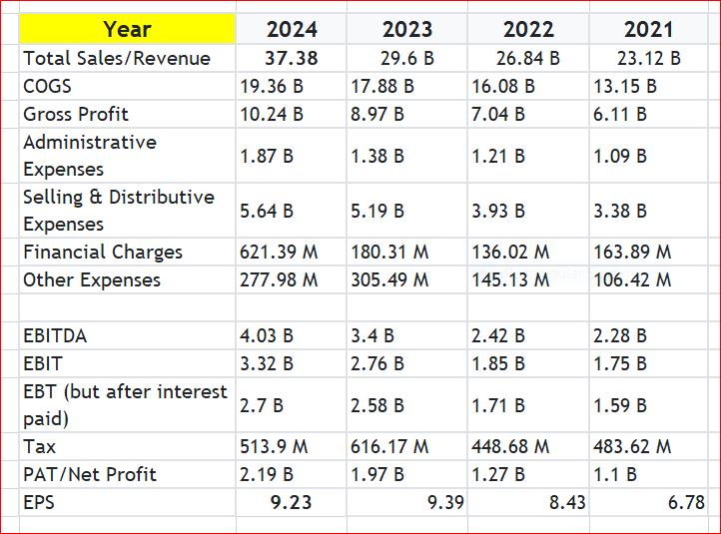

- Total Sales/Revenue: Total income generated from selling goods or services before deducting any costs.
Total Revenue = Price per unit × Quantity sold
- COGS (Cost of Goods Sold): The direct costs incurred in producing or purchasing goods sold by the company.
COGS = Opening Inventory + Purchases - Closing Inventory
- Gross Profit: The profit left after subtracting COGS from total revenue.
Gross Profit = Total Revenue - COGS
- Administrative Expenses: General business expenses like salaries, office rent, and utilities, not directly related to production.
- Selling & Distributive Expenses: Expenses related to marketing, sales, commissions, and logistics.
- EBT (Earnings Before Tax): Company profit after deducting interest expenses but before tax payments.
EBT = EBIT - Interest Expense
- EBIT (Earnings Before Interest and Taxes): Also known as Operating Profit, EBIT accounts for all operating costs except interest and taxes.
EBIT = EBITDA - Depreciation and Amortization
- EBITDA (Earnings Before Interest, Taxes, Depreciation, and Amortization): A measure of operational profitability before deducting financial and non-cash expenses. EBITDA = Gross Profit - (Administrative Expenses + Selling & Other Expenses)

Balance Sheet
The balance sheet provides a snapshot of a company's financial position at a specific point in time. It is structured around the fundamental equation: Assets = Liabilities + Shareholders’ Equity. Assets include everything the company owns, such as cash, inventory, equipment, and receivables. Liabilities cover obligations like loans, accounts payable, and accrued expenses. The difference between assets and liabilities is the shareholders’ equity, representing the owners’ residual interest. A strong balance sheet indicates good financial health and solvency. It is crucial for evaluating liquidity, leverage, and long-term stability. It is structured around the accounting equation:
Assets = Liabilities + Shareholders’ Equity.

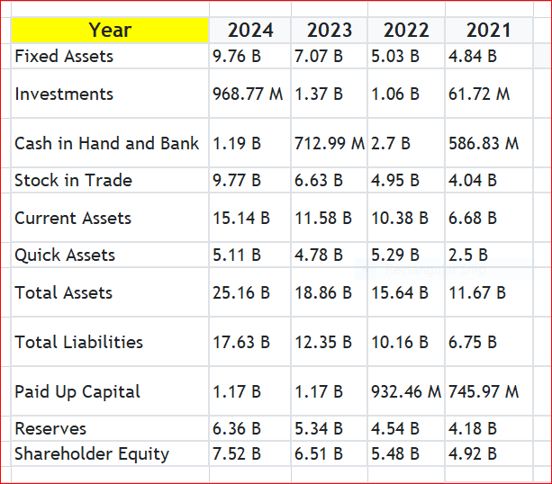

- Assets: Resources owned by the company that provide economic benefits, categorized as current assets (cash, accounts receivable, inventory) and non-current assets (property, equipment, intangible assets).
- Current Assets: Short-term assets that can be converted into cash within a year. These include cash, accounts receivable, inventory, and marketable securities. They are essential for a company’s day-to-day operations and indicate liquidity. A higher level of current assets ensures a business can meet its short-term obligations and manage unexpected expenses
- Quick Assets: Subset of current assets that can be quickly converted into cash, usually within 90 days. They include cash, marketable securities, and accounts receivable but exclude inventory. The quick ratio (quick assets ÷ current liabilities) measures a company's ability to pay off short-term debts without relying on inventory sales. This is crucial for financial stability.
- Liabilities: Obligations the company must pay, divided into current liabilities (short-term debt, accounts payable) and long-term liabilities (bonds payable, deferred taxes).
- Shareholders’ Equity: Represents the owners claim on assets after liabilities are settled, including retained earnings and common stock. A strong equity position indicates financial stability and growth potential.

Cash Flow Statement
The cash flow statement tracks the inflow and outflow of cash in a business across three main activities: operating, investing, and financing. Operating activities reflect cash generated or used in the core business, like receipts from customers or payments to suppliers. This statement helps assess a company’s liquidity and ability to generate cash, ensuring it can meet short-term obligations and invest in future growth.
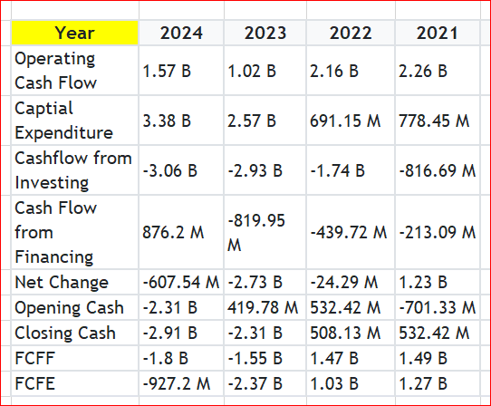

- Operating Cash Flow (OCF): Cash generated from core business activities. A positive OCF means the company can sustain its operations.
- Opening Cash Balance: The opening cash balance is the amount of cash a company had at the start of the financial period. It serves as a starting point for tracking cash movements and is reported in the previous period’s closing cash balance.
- Closing Cash Balance: The closing cash balance is the amount of cash a company holds at the end of a financial period. It is derived by adding the net change in cash to the opening balance. A higher closing cash balance provides financial security and flexibility in business operations.
- Free Cash Flow to Firm (FCFF): FCFF, or Unlevered Free Cash Flow, represents the cash available to all investors, including both debt and equity holders, after accounting for operating expenses and capital expenditures. It is calculated as: FCFF= Operating Cash Flow – Capital Expenditures + Interest Paid × (1−Tax Rate)
FCFF is crucial in valuing companies and assessing their ability to generate cash for reinvestment and debt repayment.
- Free Cash Flow to Equity (FCFE): FCFE, or Levered Free Cash Flow, measures the cash available to shareholders after accounting for all expenses, capital expenditures, and debt repayments. It is calculated as:
FCFE= FCFF − Debt Repayments + New Debt Issued
FCFE helps investors determine how much cash a company can distribute as dividends or reinvest in growth.
These financial statements collectively provide a comprehensive view of a company’s financial health, enabling investors to evaluate its liquidity, profitability, and long-term stability The balance sheet shows short-term solvency, the income statement reflects profit generation, and the cash flow statement tracks cash management. Key metrics like profit margins, debt levels, and EPS guide investment decisions. Strong, consistent financial performance signals long-term viability and lower investment risk.

. Key Financial Ratios and Their Importance
Financial ratios are essential tools used by investors, analysts, and managers to evaluate a company’s financial performance. These ratios help in understanding a company’s ability to meet obligations, generate profits, efficiently manage resources, and assess market valuation. To assess National Foods' performance, we analyze the following ratios:
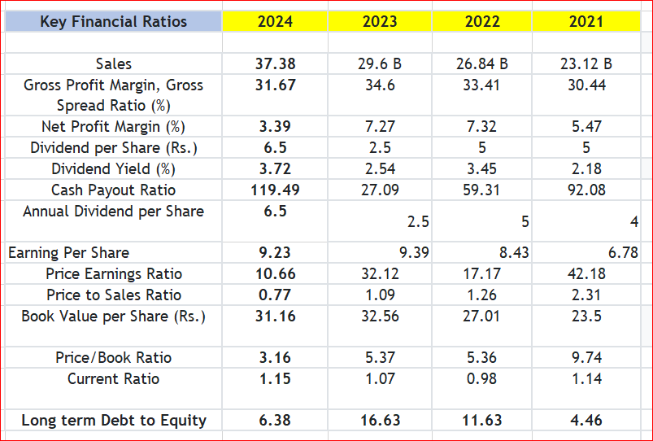

Liquidity Ratios

Liquidity ratios measure a company’s ability to meet its short-term liabilities using its current or liquid assets. These ratios help determine how easily a company can convert assets to cash in the near term.
- Current Ratio = Current Assets / Current Liabilities
Shows whether the company can pay off its short-term debts with its short-term assets. A ratio above 1 is generally healthy.
- Quick Ratio = (Current Assets - Inventory) / Current Liabilities
A more stringent measure than the current ratio, it excludes inventory since it's not always easily converted to cash.

Profitability Ratios

Profitability ratios indicate how well a company can generate profit relative to its sales, assets, or equity. These are key indicators of financial health and performance.
- Gross Profit Margin = (Gross Profit / Revenue) × 100
Measures the efficiency of production and how much profit is left after subtracting cost of goods sold.
- Net Profit Margin = (Net Profit / Revenue) × 100
Reflects the company’s overall profitability after all expenses, taxes, and interest.
- Return on Assets (ROA) = (Net Income / Total Assets) × 100
Indicates how efficiently the company is using its assets to generate profit.
- Return on Equity (ROE) = (Net Income / Shareholders’ Equity) × 100
Measures the return earned on the shareholders' investment. Higher ROE means higher profitability.

Efficiency Ratios

These ratios assess how effectively a company uses its resources, such as assets and inventory, to generate revenue.
- Asset Turnover Ratio = Revenue / Total Assets
Shows how efficiently assets are used to generate sales. A higher ratio indicates better efficiency.
- Inventory Turnover Ratio = Cost of Goods Sold / Average Inventory
Reflects how often inventory is sold and replaced during a period. Higher turnover suggests strong demand or efficient inventory management.

Leverage Ratios
Leverage ratios evaluate the company’s use of debt and its ability to service that debt. They help assess financial risk and capital structure.
- Debt-to-Equity Ratio = Total Debt / Shareholders’ Equity
Indicates the proportion of financing that comes from debt versus shareholders’ equity.
- Interest Coverage Ratio = EBIT / Interest Expense
Measures the ability to pay interest on outstanding debt. A ratio above 1.5 is generally considered safe.

Market Valuation Ratios
These ratios help investors determine whether a company’s stock is overvalued, undervalued, or fairly valued in the market.
- Price-to-Earnings (P/E) Ratio = Market Price per Share / Earnings per Share (EPS)
Shows what the market is willing to pay today for a company’s earnings. High P/E may indicate growth expectations.
- Price-to-Book (P/B) Ratio = Market Price per Share / Book Value per Share
Compares market value to book value. A P/B ratio around or above 1 indicates the market values the company at or above its actual net worth.

. Financial Analysis of National Foods

Company Overview
National Foods is a leading FMCG company in Pakistan specializing in spices, condiments, and food products. Established in 1970, it has expanded its operations both locally and internationally. The company’s financial statements provide insights into its growth, profitability, and overall market position.
Based on the company's financial statements from the years 2022 to 2024, the following analysis is conducted:

Liquidity Position
- The Current Ratio increased from 1.19 in 2022 to 1.38 in 2023, before slightly declining to 1.35 in 2024. This consistently healthy ratio (above 1) shows that the company has more assets than liabilities in the short term.
- The Quick Ratio, which excludes inventory, improved from 0.81 in 2022 to 0.91 in 2023, and remained solid at 0.89 in 2024, suggesting that the company could cover its immediate liabilities without relying on inventory sales.

Profitability Performance
- Gross Profit Margin rose steadily from 27.02% in 2022 to 31.18% in 2024, highlighting improved cost control and pricing strategy.
- Net Profit Margin, which reflects overall profitability, slightly declined in 2023 to 4.75% but bounced back to 5.61% in 2024, indicating strong bottom-line growth.
- Return on Assets (ROA) shows how efficiently the company uses its assets to generate profit. ROA decreased to 4.18% in 2023 but rose to 5.41% in 2024.
- Return on Equity (ROE), a key investor metric, dropped to 9.76% in 2023 but recovered to 11.98% in 2024, reflecting enhanced returns for shareholders.
  - Operational Efficiency
- In 2022, National Foods had an asset turnover ratio of 0.99, meaning every Rs. 1 of assets generated Rs. 0.99 in revenue.
- This declined to 0.88 in 2023, suggesting slightly lower efficiency.
- It then improved to 0.96 in 2024, showing recovery in asset utilization.
- In 2022, the inventory turnover ratio was 3.63, which means inventory was sold approximately 3.6 times a year.
- It increased to 4.37 in 2023, and slightly rose again to 4.43 in 2024.

Financial Leverage
- In 2022, the debt-to-equity ratio was 0.67, showing that for every Rs. 1 of equity, the company had Rs. 0.67 in debt.
- In 2023, the ratio declined to 0.56, indicating reduced dependence on debt.
- By 2024, it further dropped to 0.54, reflecting a steady shift towards equity financing.
- In 2022, the interest coverage ratio stood at 6.56, meaning the company could cover its interest expense over six times.
- It slightly dipped to 5.87 in 2023, but remained in a safe range.
- In 2024, the ratio surged to 10.03, a significant improvement showing enhanced earnings and financial stability.

Market Performance
- In 2022, National Foods had a P/E ratio of 7.73.
- It slightly decreased to 7.27 in 2023, then rose to 8.41 in 2024.
- The P/B ratio was 0.93 in 2022, increased to 0.97 in 2023, and reached 1.01 in 2024.

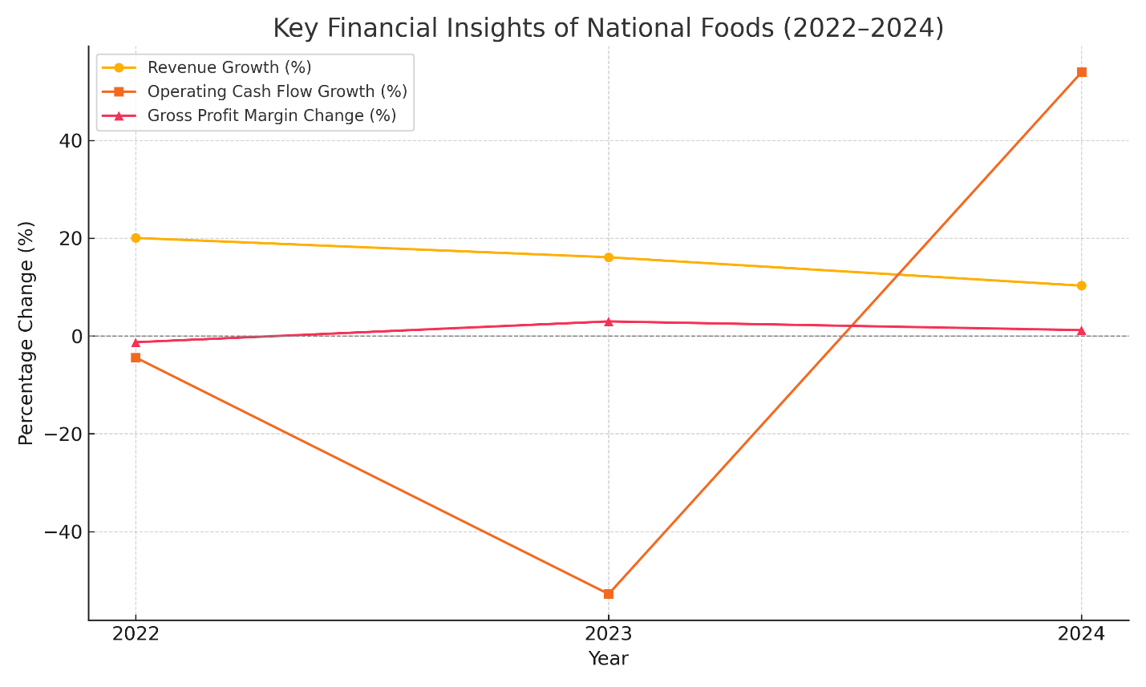

. Conclusion & Investment Decision
From 2022 to 2024, National Foods Ltd. showed consistent growth and strong financial performance. The company’s liquidity ratios, including current and quick ratios, stayed above 1, meaning it had enough assets to meet short-term obligations comfortably. Its profitability improved, with both gross and net profit margins increasing steadily. The company demonstrated efficient use of resources, as reflected in its high return on assets (ROA) and return on equity (ROE), which also contributed to solid returns for shareholders. Net income grew consistently, indicating that the company's core business operations were strong. The company also reduced its financial risk by lowering its debt-to-equity ratio and increasing its interest coverage ratio, signaling a safer, more stable capital structure. Efficiency ratios, such as asset turnover and inventory turnover, showed that the company was effectively managing its resources to generate revenue. From a market perspective, the price-to-earnings (P/E) and price-to-book (P/B) ratios suggest that the company is fairly valued, with potential for future growth as earnings continue to rise. This reflects strong investor confidence in its future prospects. National Foods’ strong brand, efficient operations, and solid financial health make it an attractive long-term investment. While market conditions and economic factors should be kept in mind, the company’s fundamentals offer a favorable outlook. A careful but optimistic approach to investing in National Foods Ltd. is recommended.

References
- National Foods Financial Reports
- Pakistan Stock Exchange
- sarmayaa.pk
- Ahmed, S., Qureshi, M. A.: Financial performance evaluation of food sector firms listed on PSX: A case study of National Foods, Pakistan Journal of Commerce and Social Sciences, 14 (2) (2020), 301–315.
- Financial Analysis Textbooks & Online Sources

